2.1 Digital Circuits

Gates and Truth table

Build a combination circuit with gates

Common combinational circuit modules

Decoder and multiplexor

Basic Arithmetic logic unit ALU

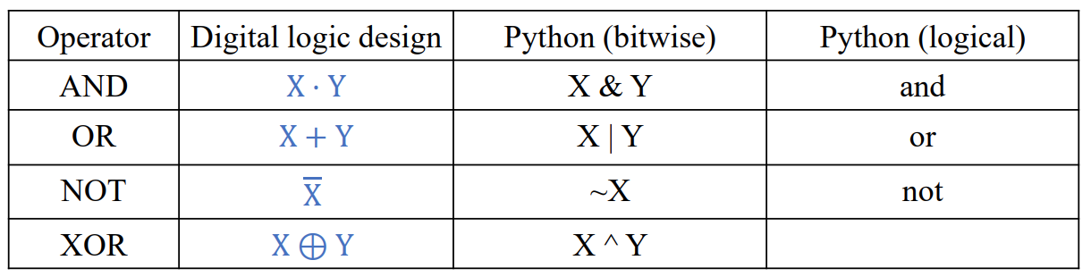

The Value of a bit is represented by the states of the circuit elements

Controlling the switch we can set the signal to 0 or 1

Gates to compute bits

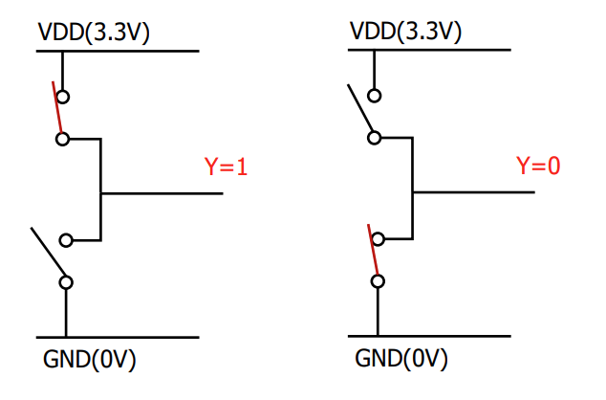

Gates are small circuit that computes on bits

A network of switches in each gate sets the output to 0 or 1

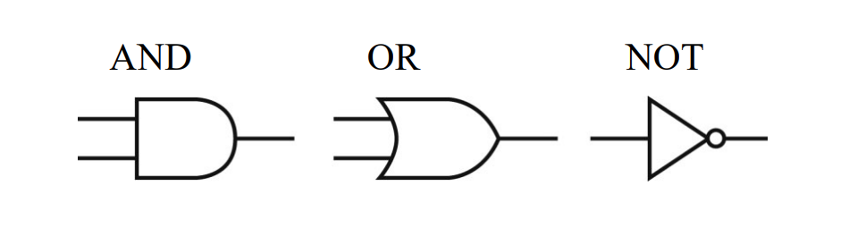

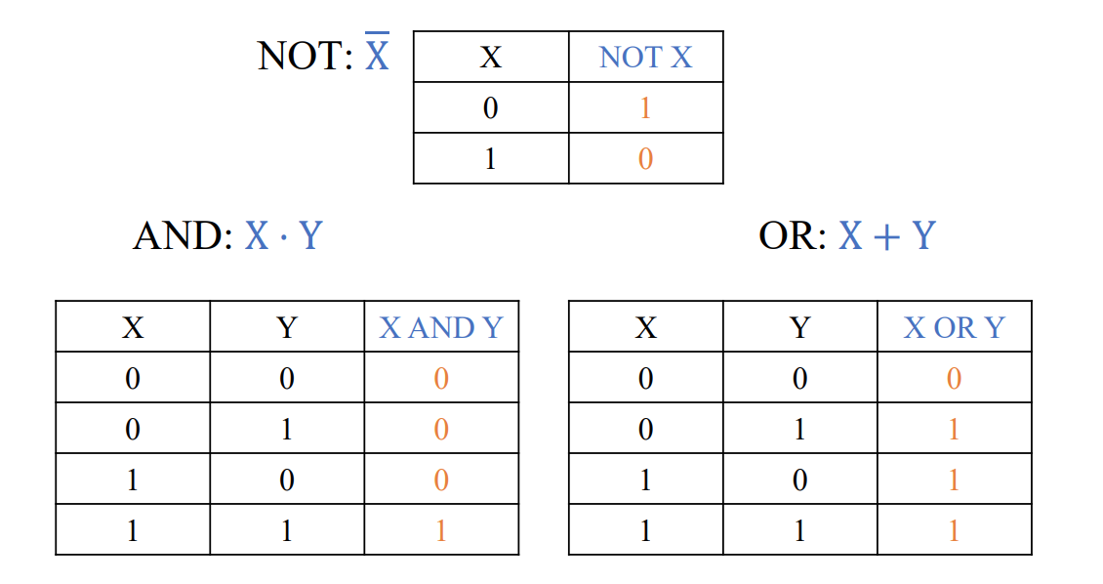

Circuits:

1. Combinational: the output depend on the current input values
2. Sequential: the output depends also on the history of inputs
   1. Two identical sequential circuits may produce different outputs even if their current inputs are the same

Variable = logic expression, (boolean expression)

Literal: a variable or its complement, for example, X ,`X, sel

Expression: liters combined by AND, OR, () and NOT

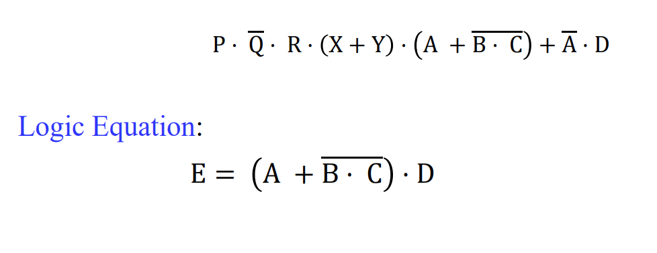

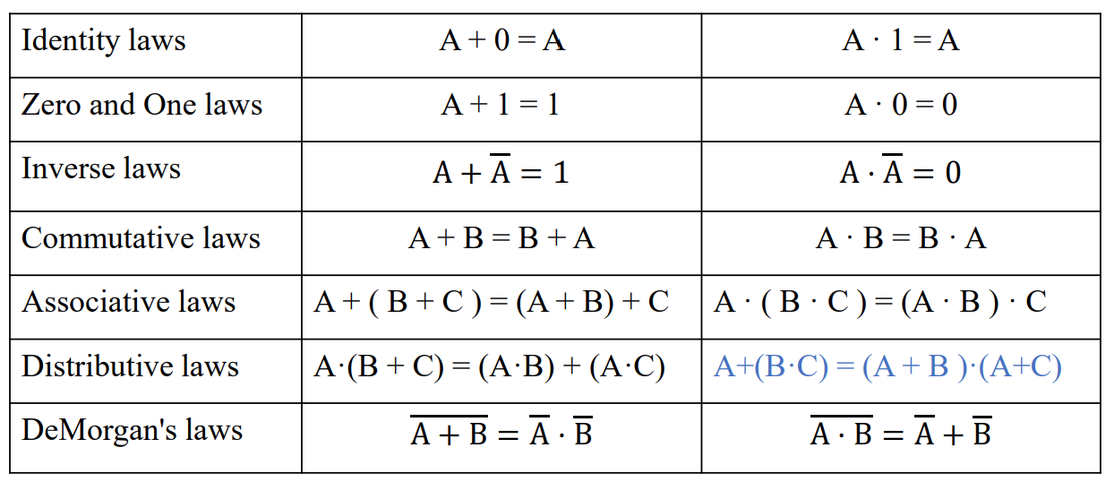

* Product term: A single literal or product (AND) of two or more literals
  + A, `B, A\*B,
* Sum term: A single literal or logical sum (OR) of two or more literals
  + A, `B, A+B

0 or 1 can be assigned to a variable

Sum-of-product: A logical sum of product terms

All logic expressions can be represented as a sum of product

If we have a logic expression, we can transform it into a sum of product

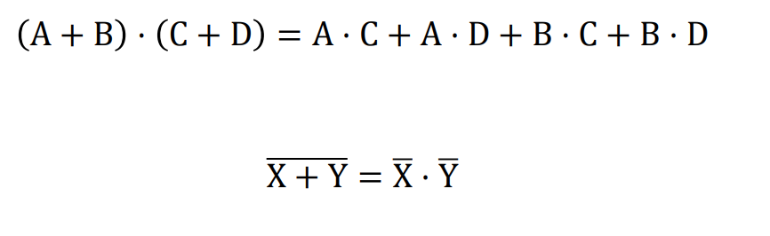

Writing a logic equation from a truth table

1. Write a product term for each row where the function outputs 1
2. Write a sum of products by ORing all the product terms

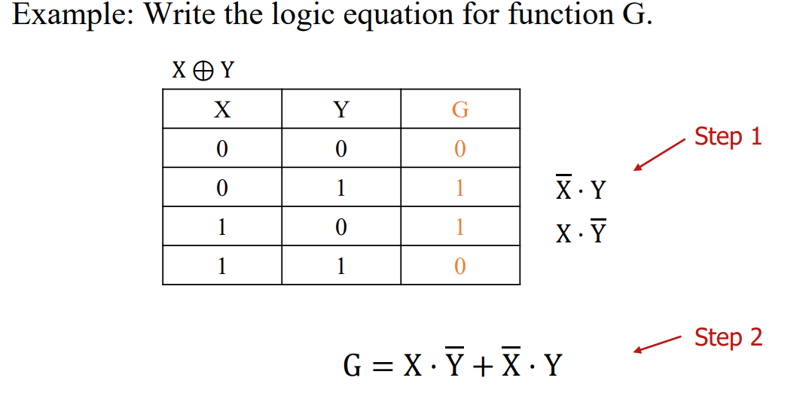

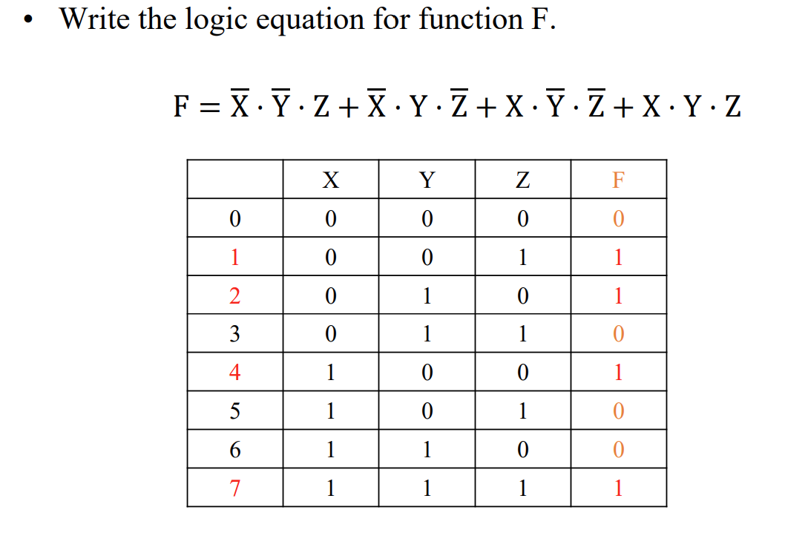

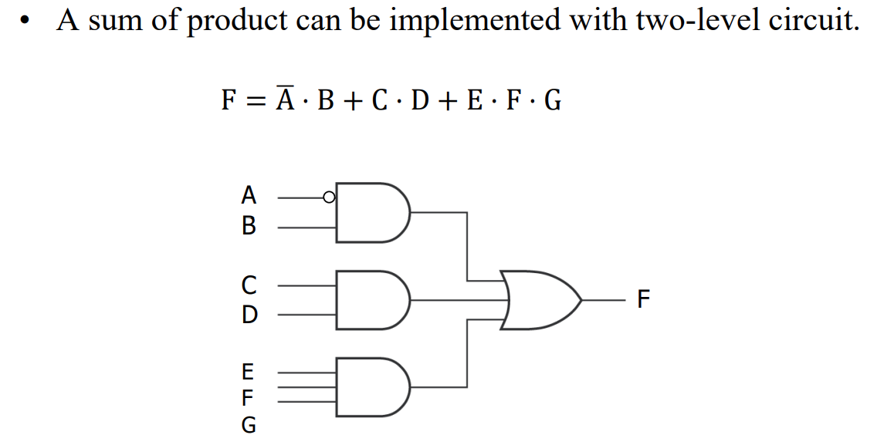

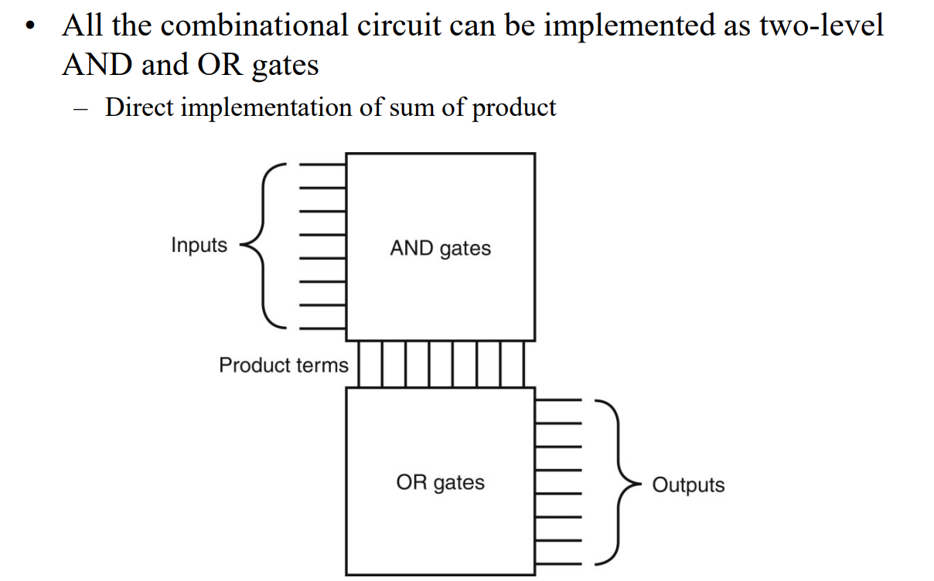

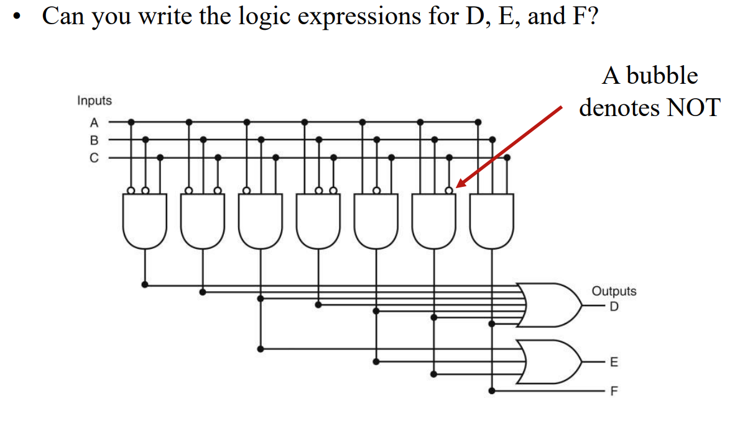

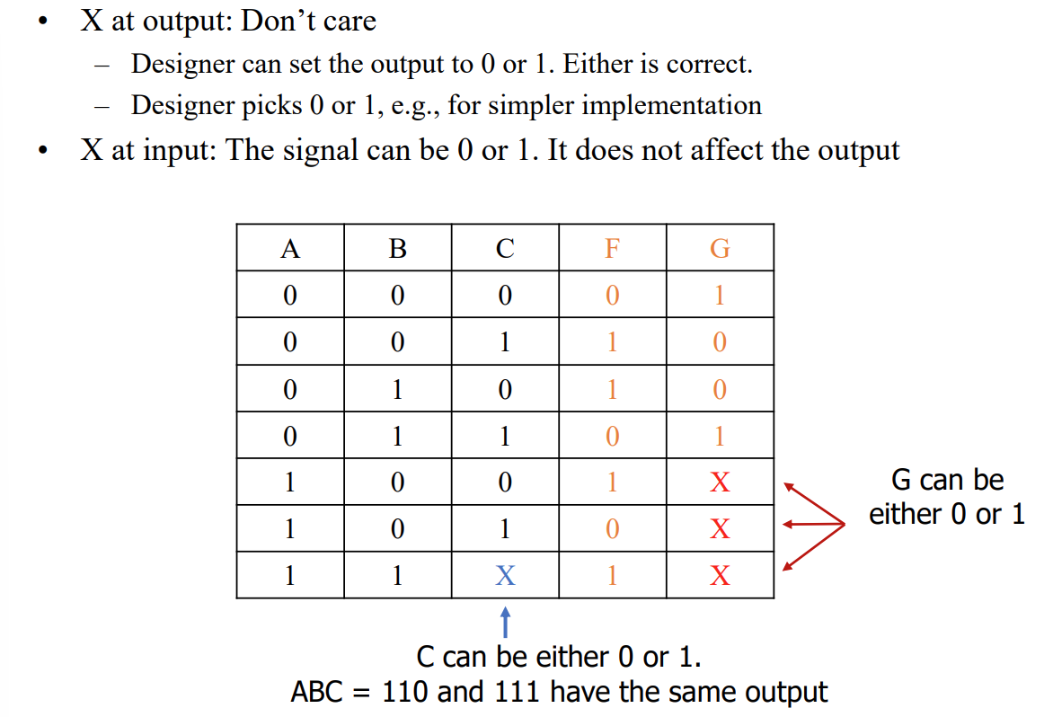

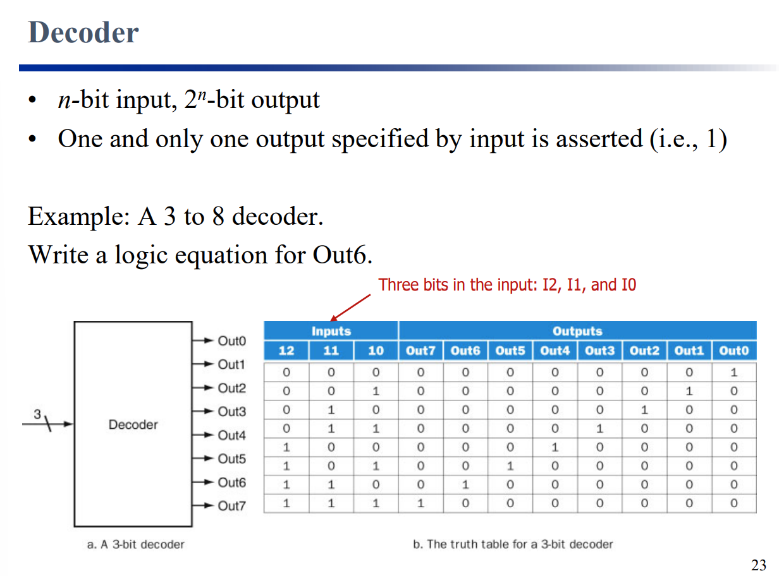

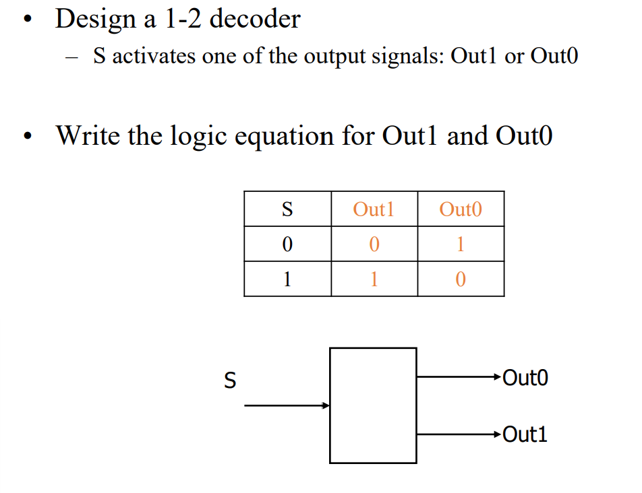

Multiplexor (MUX)

Selects one out of multiple data sources

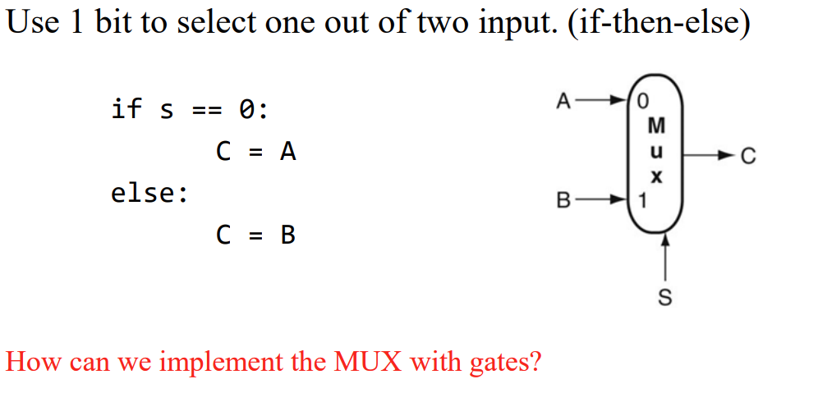

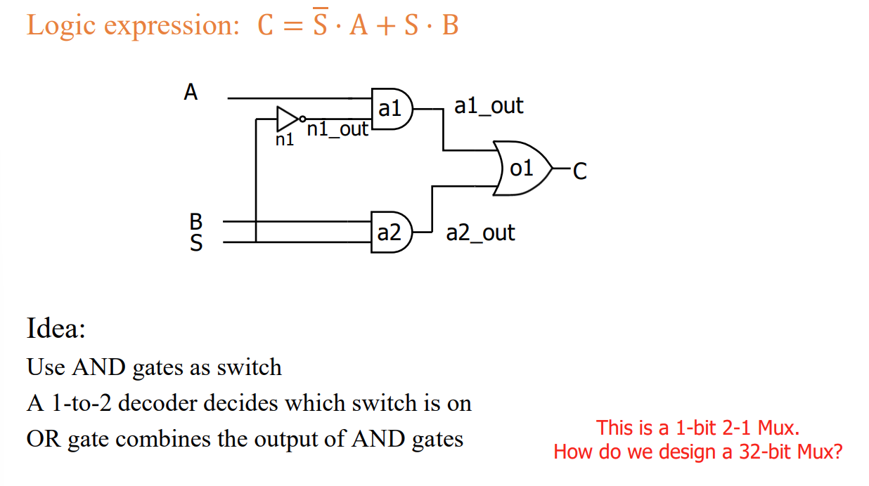

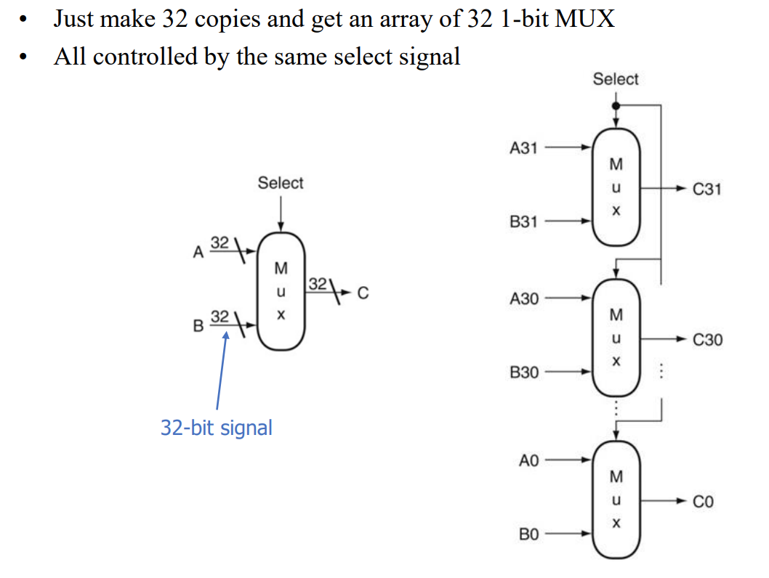

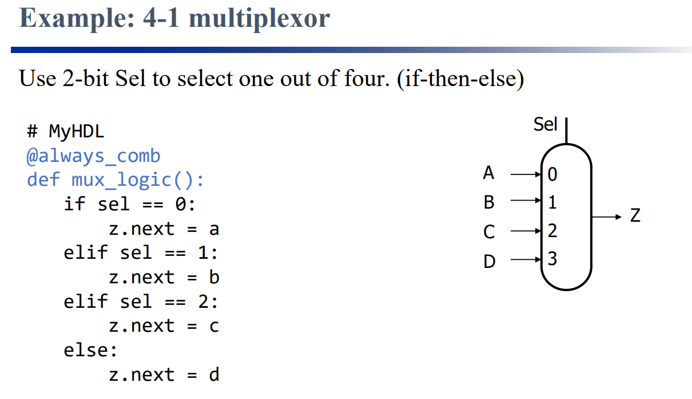

4-1 Multiplextor

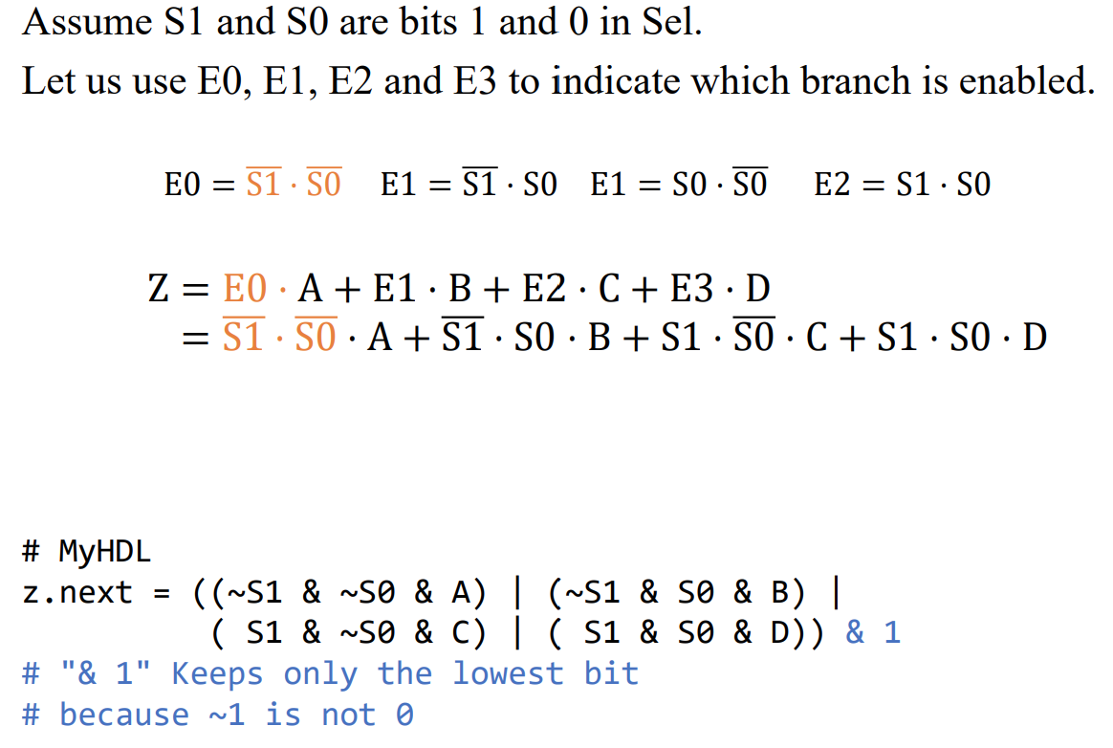

1-bit full adder

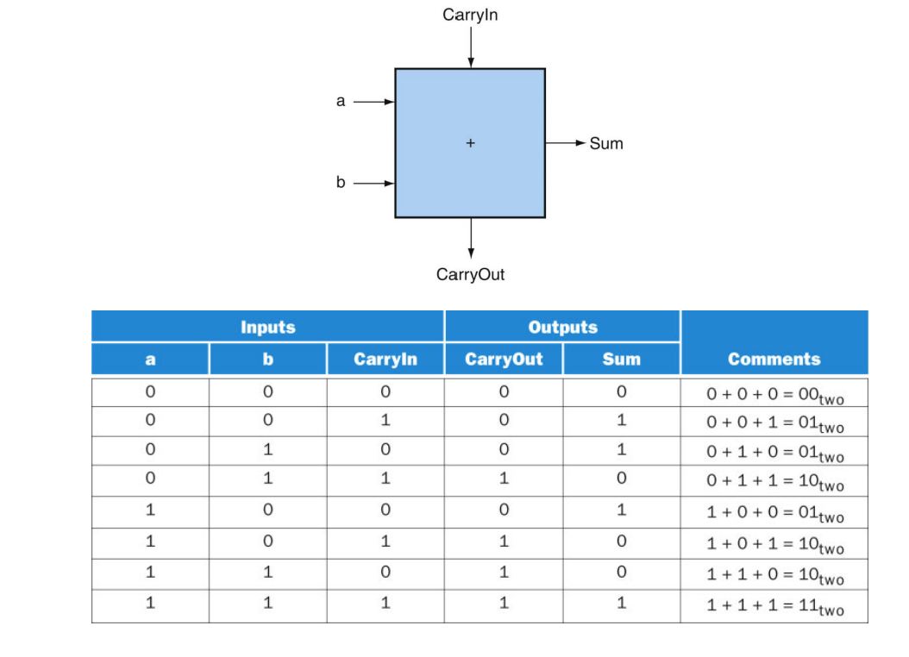

Generating CarryOut

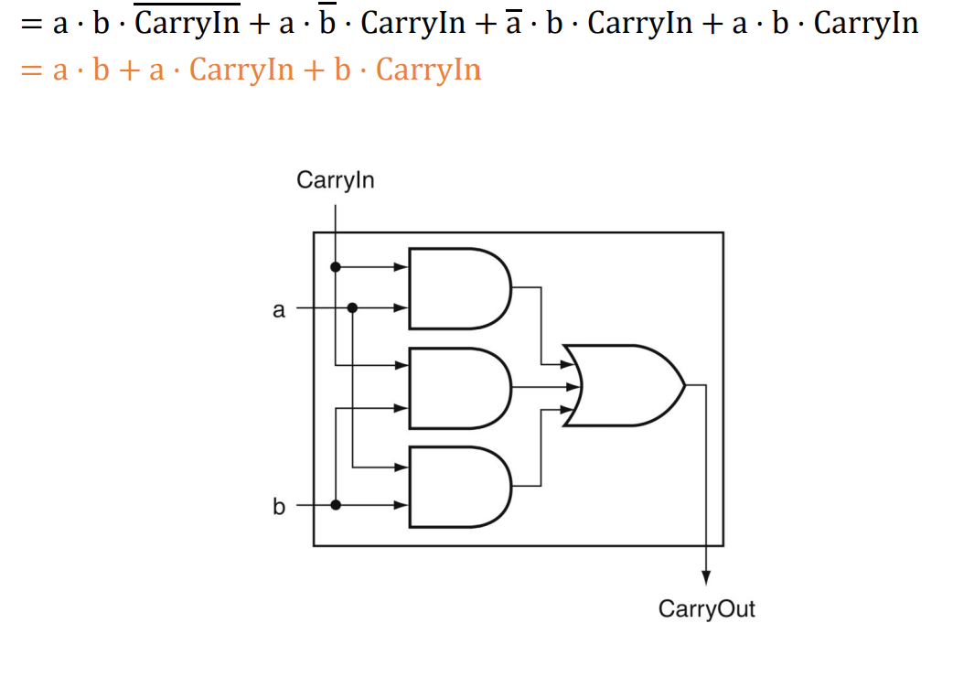

Calculating sum

